Computer Vision Homework 1

Oron Barazani 305295818 & Roee Hadar 206390098

Part 2

* 1. We draw $nBits=256$ samples for $x,y$ pairs from discrete uniform distribution $x,y \sim U[0,patchWidth^{2})$ where $patchWidth=9$ and saved the test pattern for later use.
  2. We wrote $computeBrief()$ function that check for each feature point check if it is in appropriate region (i.e. not in the margin) and then compute its binary descriptor according to the sample pattern from 2.1
  3. We combined feature extraction form part 1 (DoG detector) to construct $briefLite()$ function which take image as input, detect its key-points, and compute appropriate descriptor for each key-point.
  4. We used the provided functions $briefMatch()$ and $plotMatches()$ to test the new $briefLite()$ descriptor that we constructed in 2.3. Here are few examples:

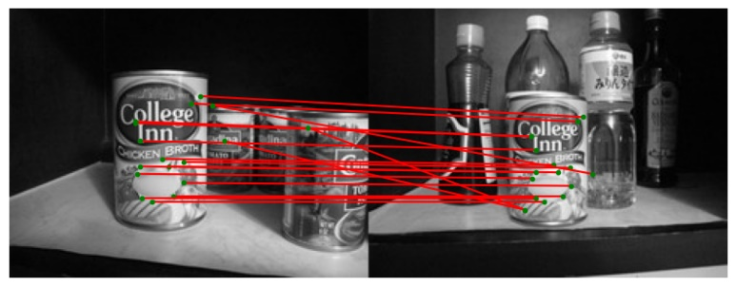

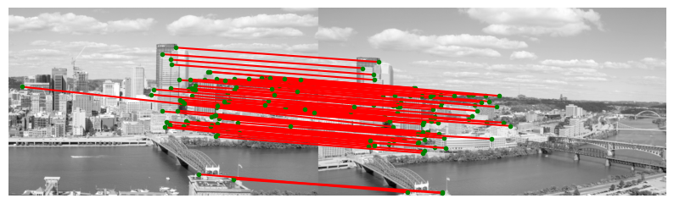In the first example we can see there is a match between the chicken broth can only, because it’s the only item that appears in both pictures. Around 500 features were extracted through DoG detector and BRIEF managed to pick only those who are matching in both images with great success.

Same things happen for incline_L/R images. Only the portion of the image that appears in both of them, is being correctly match. This is pretty challenging for any feature matching mechanism, because the city is has pattern of building which are can be easily confused for one another. Another thing we noticed is the long run time for larger images, which may be problematic (63.4 [s])

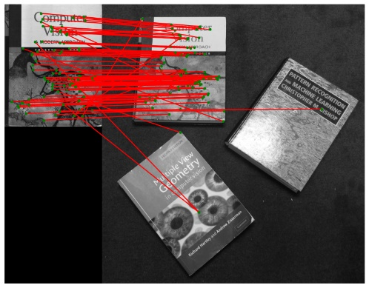

In the booking matching section, the books had good matching, where they were about the same orientation as the example image. On the other hand, the images where the book was rotated the matching was poor:

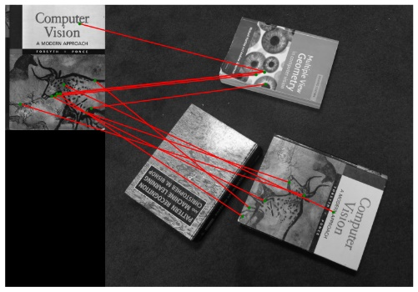

This is not surprising, because BRIEF is not rotation invariant algorithm.

* 1. Question from the notebook:

**Q: Is BRIEF invariant to illumination changes?**

A: No. BRIEF is relying on spatial intensity comparison which may be sensitive to illumination changes. The descriptor can be changed greatly for small intensity variation.

**Q: Assuming we want to boost the invariance of BRIEF to scale, which part of the SIFT algorithm should we include?**

A: We can add another dimension to the DoG pyramid and create extended scale-space - $DoG(x,y,σ,s)$ instead of ours $DoG(x,y,σ)$. The different $s$ levels, called octaves, are subsampling of original image. This allows us to deal with scale variance of the features.

In the next part, we took the chicken broth image and test BRIEF rotation invariance, which was poor. The number of matches is higher for only small rotation. The matching is poor because the descriptor is relying on spatial sampling pattern which is very sensitive to rotation. There is an interesting peak around $180°$ rotation maybe because the can is symmetrical in the X axis.

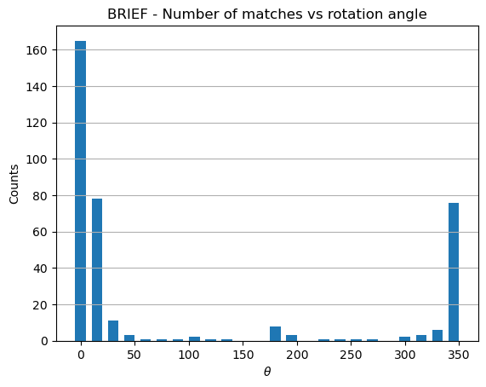

* 1. The key difference that makes ORB rotation invariant is using descriptor rotation. It takes each feature and using rotation matrix to rotate the descriptor K times in 12 degrees increments. This way, each feature, has a set of K descriptor orientation, and become rotational invariant. This method of assigning orientation for each descriptor is inspired by SIFT.

